Individual Exercise: Plan Before You Build
TASK: In this individual exercise, you will audit your existing prototype to identify the technical gaps between your static UI and a live system. Your goal is to map your data, user roles, and failure points to create a functional execution plan before you start building.
Pre-Work: Current Prototype Audit
Data Status | What data is currently hardcoded into your prototype, such as user info, metrics, content, or settings.  What data should come from a real database instead of being baked in?  ✍️ Add your list of current list of hardcoded data.  ✍️ Note what data you want to be pulled live.
User Status | Who are the different users of your prototype?  If you have more than one, should they see different things? Consider roles, permissions and personalization requirements..  ✍️ List each of your users and their specific requirements.
Error/Data Handling Status | What would break in your prototype if the data source is slow or unavailable?  ✍️ Name the screens or features that would be blank or frozen.

Lab Exercise: Add Data Schemas and RLS Authentication To Your Prototype
TASK: In this hands-on lab, you will move to a functional system. Your goal is to use the Integration Planner to configure your backend, execute 3 specific prompts in Lovable, and document the results. Success is measured by your data surviving a page refresh and your Row-Level Security (RLS) protecting user privacy.

🆘 Need Help? We’ve got your Integration Planner resource here so you can easily copy and paste the details.

Step 1: Select Your Scenario
Before you build, anchor the tool in your specific project logic.
- Select your scenario and the tool will auto-populate a suggested schema and edge cases.
- Verify the final details of your current Module 4 build, including screens, if your PRD is ready and if the code is refactored.
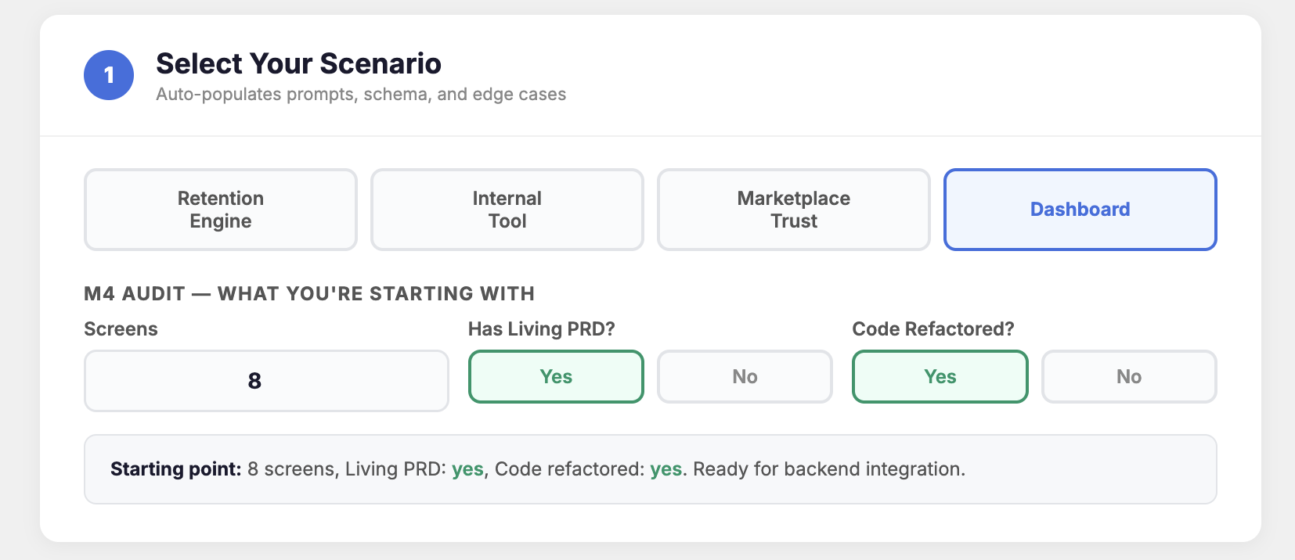

Step 2: Finalize Your Database Schema
This is where your pre-work audit of your ‘Data Status’ from the individual exercise meets the Planner Tool.
- Look at your list of current hardcoded data from your audit. In the Database Schema section of the Planner, ensure there is a corresponding Table and Field for every placeholder you identified
  - e.g., if "User Department" is hardcoded, ensure the users table has a department field
- Review the additional suggested tables provided by the planner. Delete any that don't apply to your scenario and add specific fields to match the unique metrics or content you want to make live.
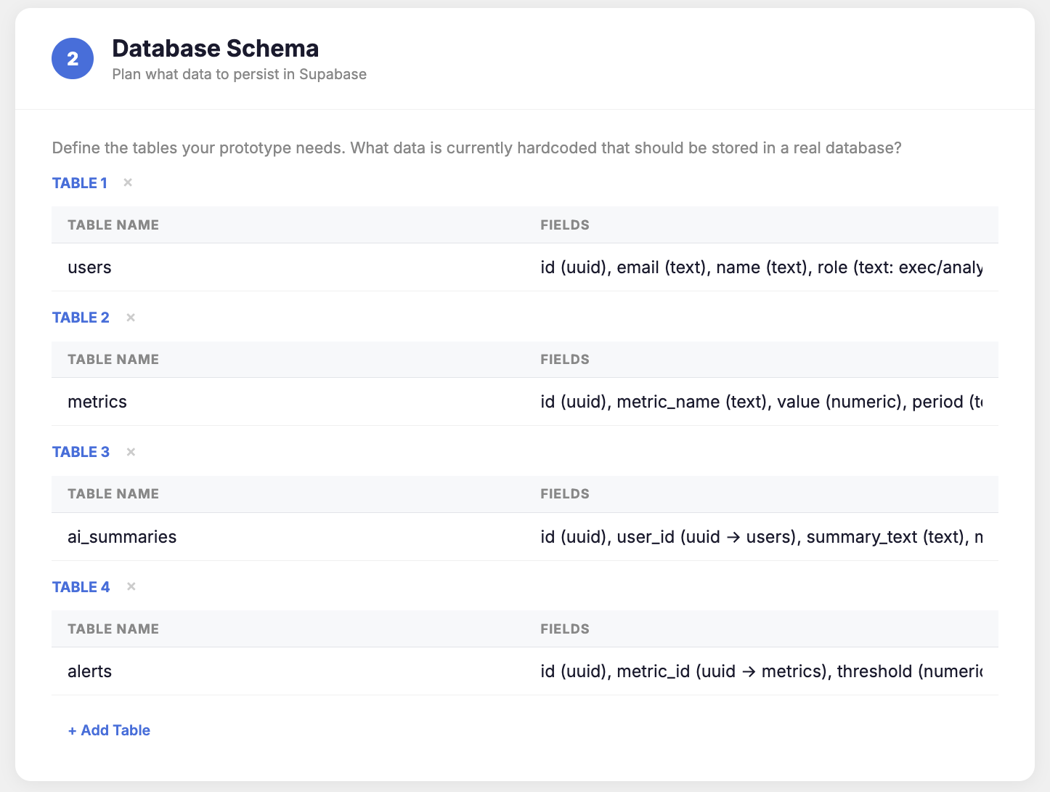
- Scroll down to find your pre-built first prompt. Check that any changes you made to the database schema are reflected and then press “Copy Prompt.”
💡 Pro-Tip: If the Planner feels like it’s slowing you down, pivot! The tool is a resource, not a cage. You can grab the Template section and fill in your own details, or feed that template to an LLM to help you craft a custom prompt. Don’t let the resource get in the way of your build.
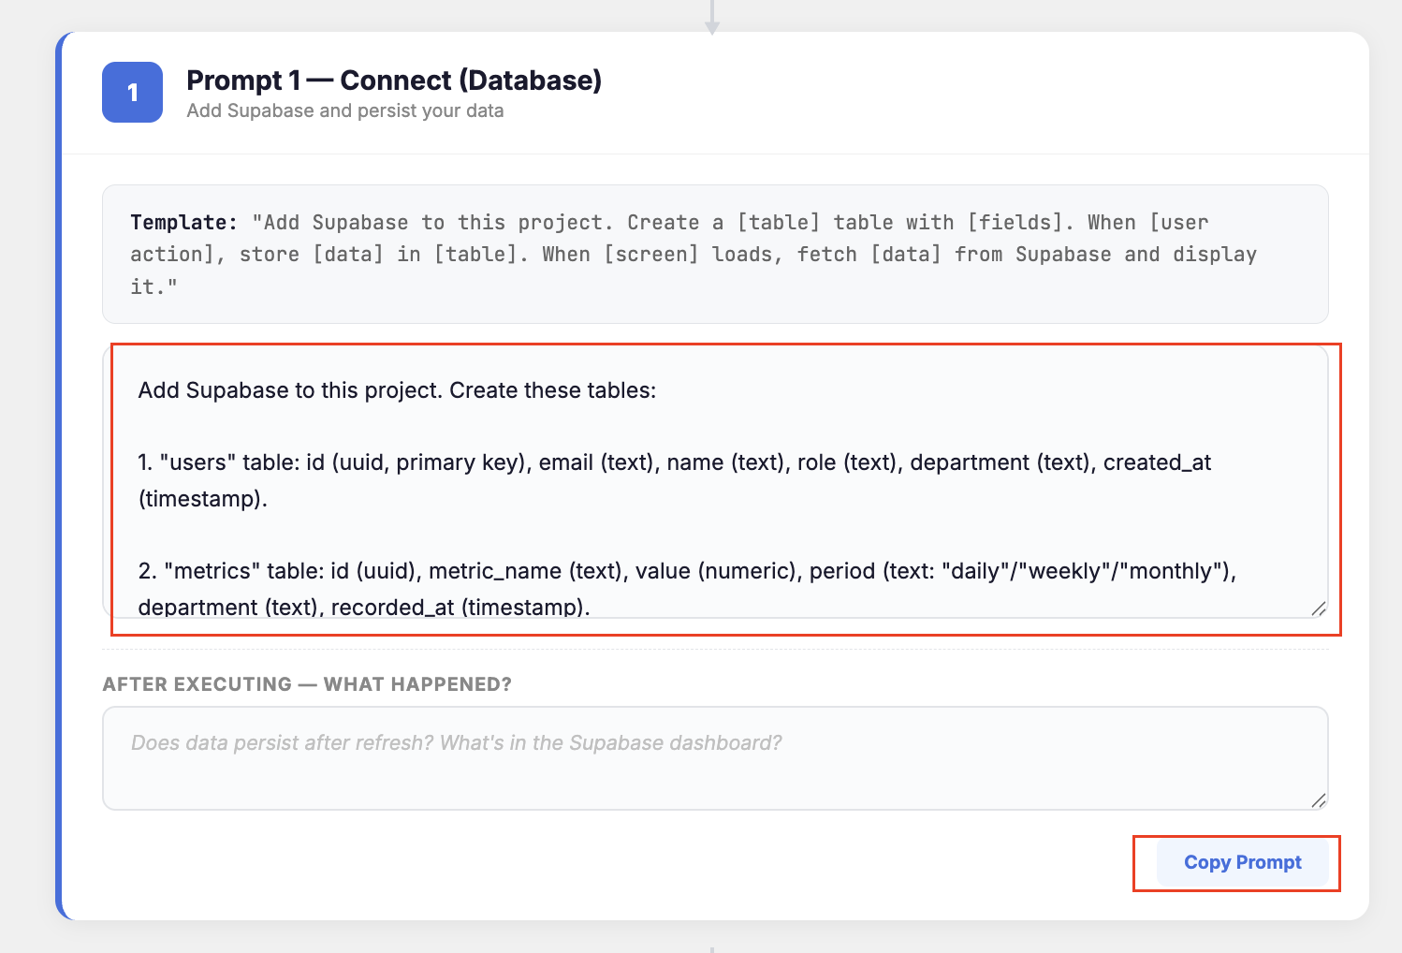
- Bring your copied prompt into your Lovable project, paste it into your chat and hit run.
- Once the build is finished, manually enter a piece of data into your app. Refresh the browser. If the data remains, you have successfully replaced your hardcoded UI with a live Supabase connection!
🆘 If the data did not persist, check the following:
- Check the Connection: Go to the Settings > Integrations tab in Lovable. Ensure your Supabase project is still showing as "Connected." If it’s disconnected, re-link it.
- Check the Tables: Open your Supabase Dashboard. Do the tables actually exist? If the tables are there but the data is gone, the issue is likely your Fetch Logic (the "how" the app talks to the table), not the table itself.
- The Logic Re-Prompt: If the build failed, don't just say "it didn't work." Provide context to the AI:
E.g., "The 'metrics' table exists in Supabase, but the UI is still showing the hardcoded numbers. Update the [Screen Name] to fetch the 'value' field from the 'metrics' table."

Step 3: Activate Your Secure RLS Authentication
This is where you move to a multi-user system. You are mapping your "User Status" audit, specifically the different roles and permissions you identified earlier, into the Planner’s Auth Mode
- In the Authentication Flow section of the planner, confirm the specific permissions for your roles (e.g., what an "Executive" sees vs. an "Analyst") actually align with the users you identified earlier and make adjustments as needed. This ensures your Row-Level Security (RLS) is actually protecting the data you just connected in Step 2.
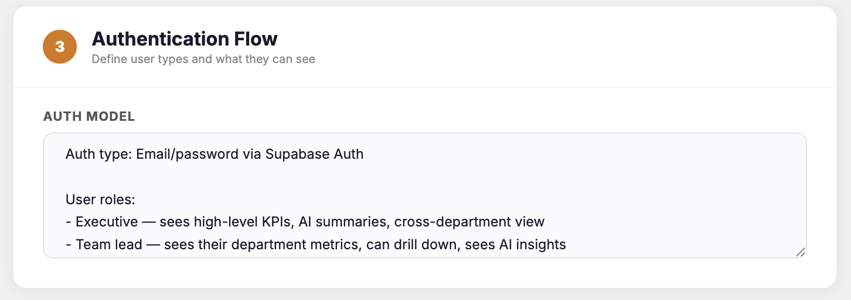
- Scroll down to the second pre-built prompt, in the Authentication section of the tool. Check that any changes you made to the user permissions are reflected and then press “Copy Prompt.”
- Remember, if you prefer to practice prompting on your own, just use the Template section as a guide or bring it to an LLM to help you craft your own.
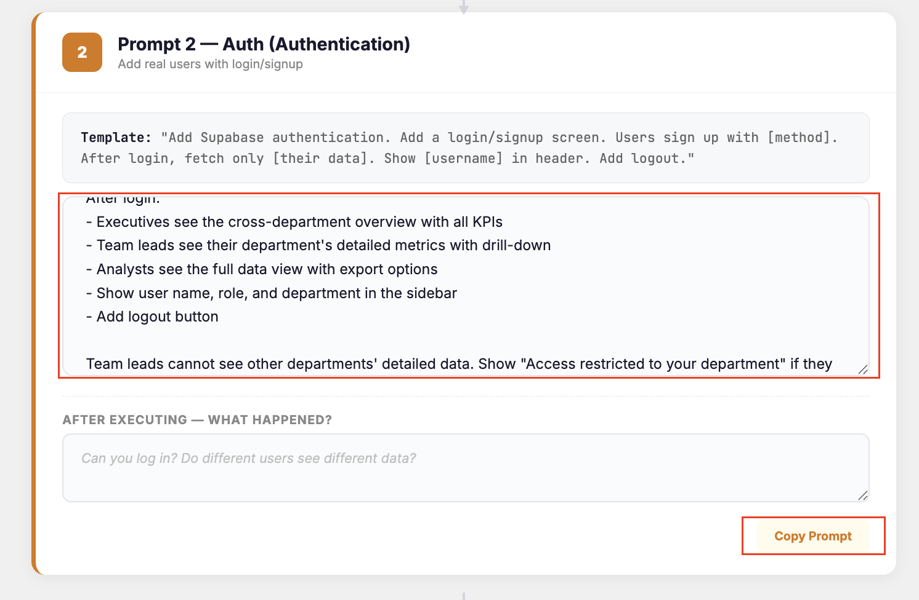
- Bring your copied prompt into your Lovable project, paste it into your chat and hit run.
- Once the build is finished, you must verify that your data is actually private. Perform this exact sequence.
- Step 1: Create Account A
Sign up, log in, and enter some data (e.g., a specific metric or profile detail).
- Step 2: Log Out
Ensure you are fully signed out of the application.
- Step 3: Create Account B
Sign up with a different email address and log in.
If Account B cannot see the data you entered for Account A, your Row-Level Security is successfully verified!
🆘 If you can't log in or your access is blocked, check the following:
- Check the Auth Provider: In your Supabase Dashboard, go to Authentication > Providers and ensure "Email/Password" is enabled.
- The Logic Re-Prompt: If you can log in but see "Access Restricted" on every screen, tell the AI:
E.g., "I am logged in as a [Role], but I cannot see the [Table] data. Update the RLS policy to allow [Role] to read from the [Table] where the ID matches."

Step 4: Build Edge Case Resilience
A true professional product doesn’t just "break" when the connection is slow or data is missing. In this step, you are using your Error/Data Handling Status audit from earlier and the Planner’s Edge Case Checklist to check where your gaps still lay.
- Review the Edge Case Checklist in the Planner. Identify which failures are most critical for your specific scenario. You must have at least two: one for a loading state and one for an error state.
  - E.g., if you have a dashboard, a Loading State is non-negotiable; if you have a login, an Invalid Credentials message is a must.
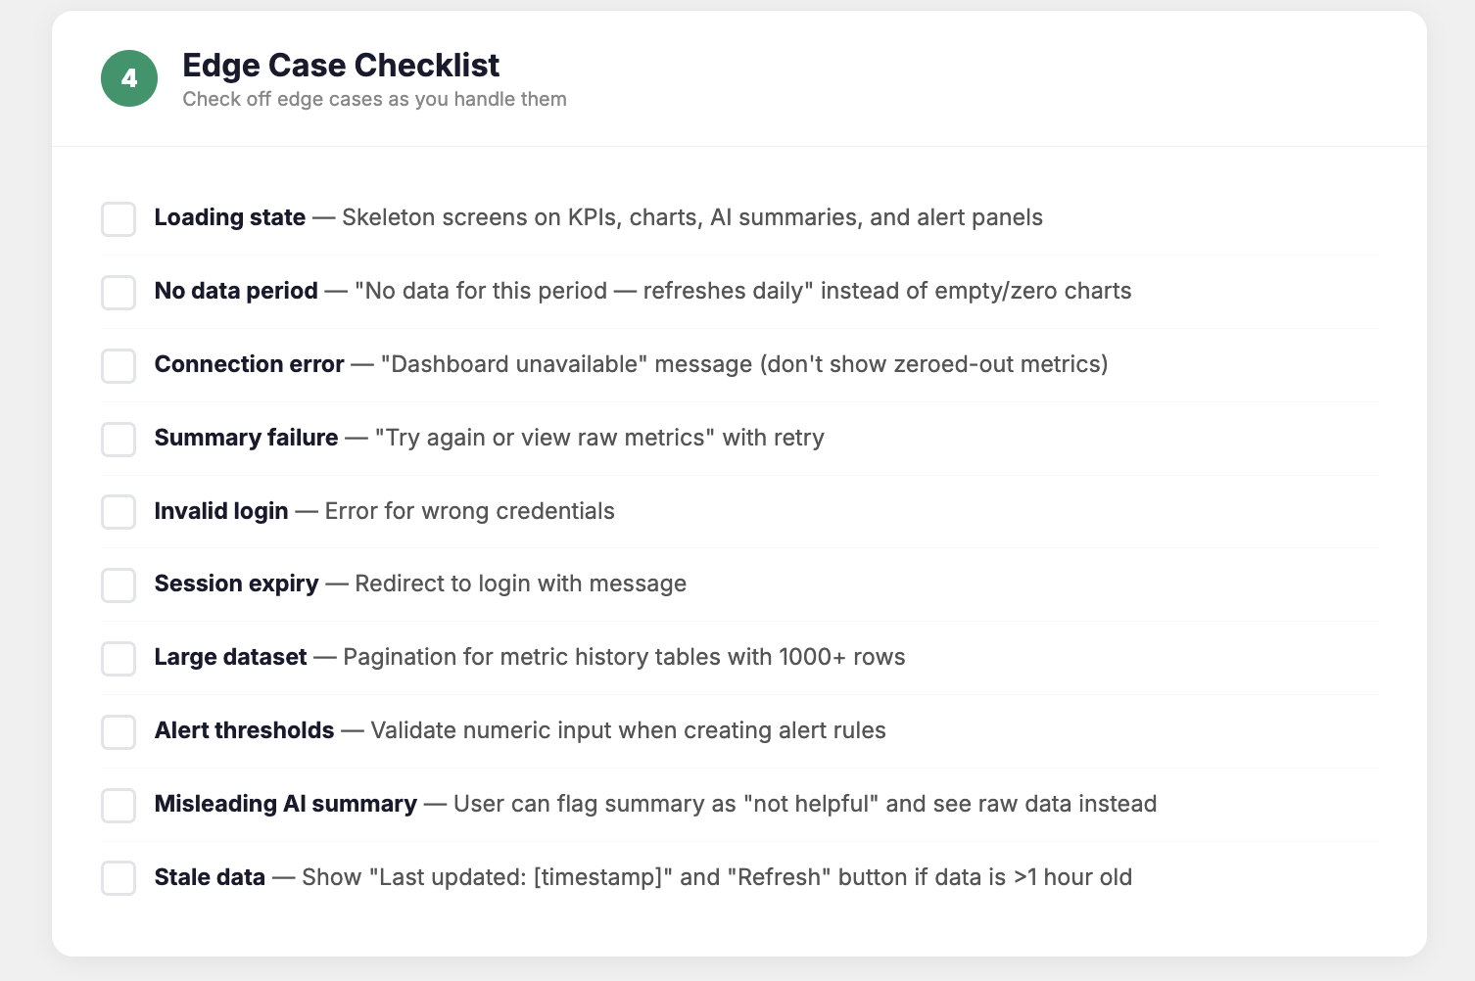
- Scroll down to the third pre-built prompt, in the Edge Cases section of the tool. Check that any changes you made to the failure modes are reflected and then press “Copy Prompt.”
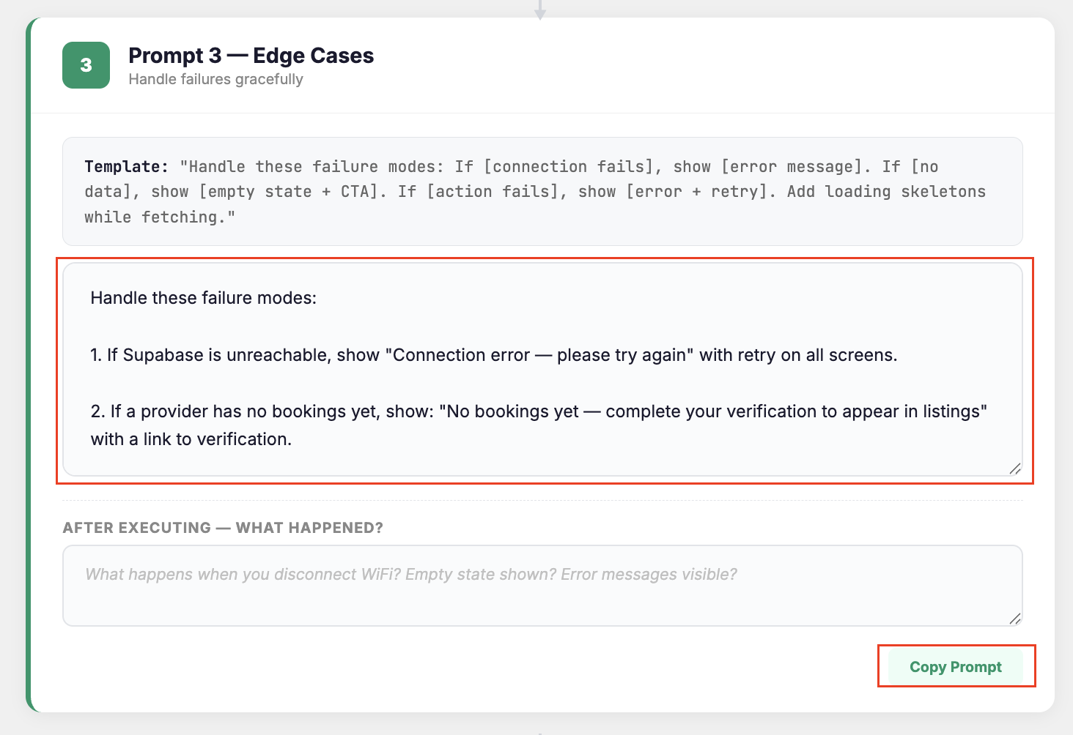
- Bring your final copied prompt into your Lovable project, paste it into your chat and hit run. This should harden your UI to handle the messy reality of live data.
- Once the build is finished, you must verify that your new edge cases are functional:
- The Loading Test: Refresh your browser on your most data-heavy screen. Do you see skeleton screens, a spinner, or a "Loading..." message while the app fetches your data?
- The Error Test: To see your error handling in action, you can manually trigger a failure. In Lovable, tell the AI: "Simulate a database timeout for the [Main Screen] and show me the error state." Does a clear error message or "Service Temporarily Unavailable" notification appear? Success is a UI that communicates the problem to the user instead of simply "freezing" or doing nothing when a button is clicked.
If you see your loading skeletons and error messages, you’ve successfully implemented your edge case handling!
🆘 If your edge cases aren't triggering:
- The "Flash of Invisible Content": If your data pops in but you never see a skeleton screen, your connection might be too fast for the UI to register. To test it, tell the AI:
E.g., "Artificially delay the data fetch by 2 seconds so I can verify the loading skeleton is rendering correctly."
- The "Frozen" UI: If you simulate an error (like logging out or disconnecting) and the app just stays on a blank screen with no message, the error isn't being caught. Tell the AI:
E.g., "The app is failing silently on a network error. Add a 'try/catch' block to the fetch function and display a visible Error Toast or 'Service Unavailable' message to the user."

Instructor-Led Exercise: Rapid-Fire Stress Test and Deploy Your Product Live
TASK: In this individual exercise, you will subject your finalized prototype to a real-world stress test to identify technical vulnerabilities. Your goal is to audit your system’s resilience, decide if it meets launch criteria, and trigger your live deployment to a public URL.

Step 1: Choose & Run Your Chaos Stressor
Pick one of the following scenarios to run on your current Lovable build. Do not spend more than 2 minutes deciding; the goal is to see how the system handles a single point of failure.
- Option A: The Kill Switch: Open DevTools > Network and set to "Offline."
  - Does your UI acknowledge the disconnection, or does it simply hang?
- Option B: The Ghost User: Sign up with a brand new email.
  - Does the user see an active empty state with a CTA, or a blank screen?
- Option C: The Spam Click: Hit your “submit" button 5 times rapidly.
  - Does your database create 5 duplicate records, or is the transaction handled correctly?

- Run your chosen test and watch the interface closely and identify exactly if/where the logic reaches its limit.

Step 2: Update Your Engineering Handoff
Based on your results, categorize the failure and take immediate action.
- Write your results in the table below
Stress Test Notes | ✍️ Log your results here. If it did not pass, is it a P0 blocker?  If its a minor glitch, keep as is and document it in your updated handoff note for engineers.
- Update your “Handled vs. Known Gaps” in the Engineering Handoff Note section in the Integration Tool from earlier. For example, if you found a "Spam Click" duplicate, document it as a technical requirement for the engineer.
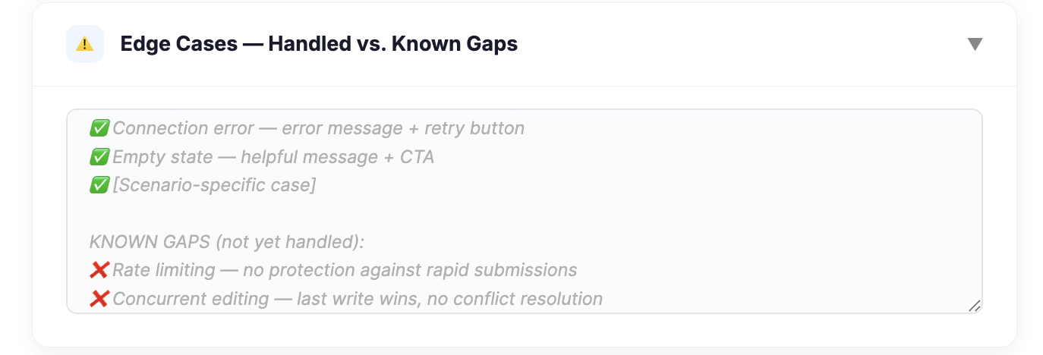

- Once your documentation reflects the actual state of the build, click "Export .md" or "Copy All" to save your final Integration Plan.
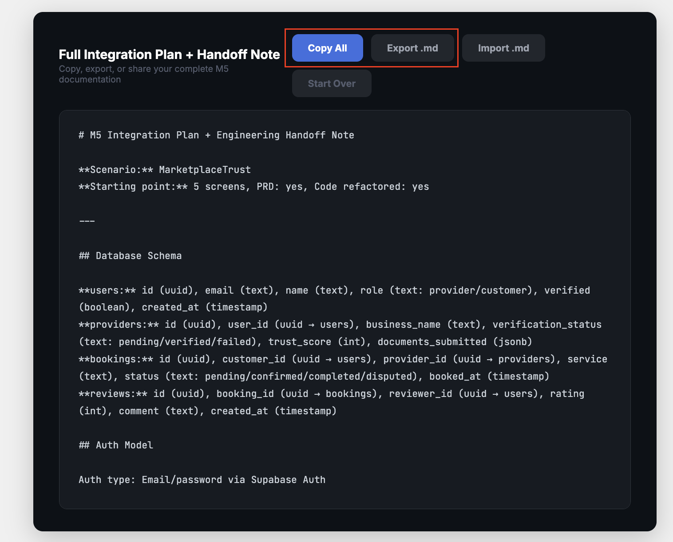

Step 3: Deploy Your Product
With your documentation finalized and your known risks accounted for, it’s time to ship!
- Trigger the live deployment in Lovable to generate your public production URL by clicking the “Publish” button in the top right corner of your project. Don’t worry about the details yet - just press “Continue” and then “Publish.”
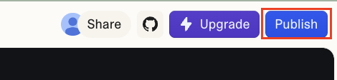
- Copy your live URL and prepare to share it alongside your Handoff Note. You have officially moved from a prototype to a product! Congratulations!
Live URL | ✍️ Add your live URL here for safe keeping.

